**User Manual**

**Steps for installing the application In MacBook**

**Step 1:** First you need to download the code from GitHub:

Click on this link: <https://github.com/Haritha-Atmakuri/RationBalancing>

After redirecting you will find an option as clone or download. Click on clone button

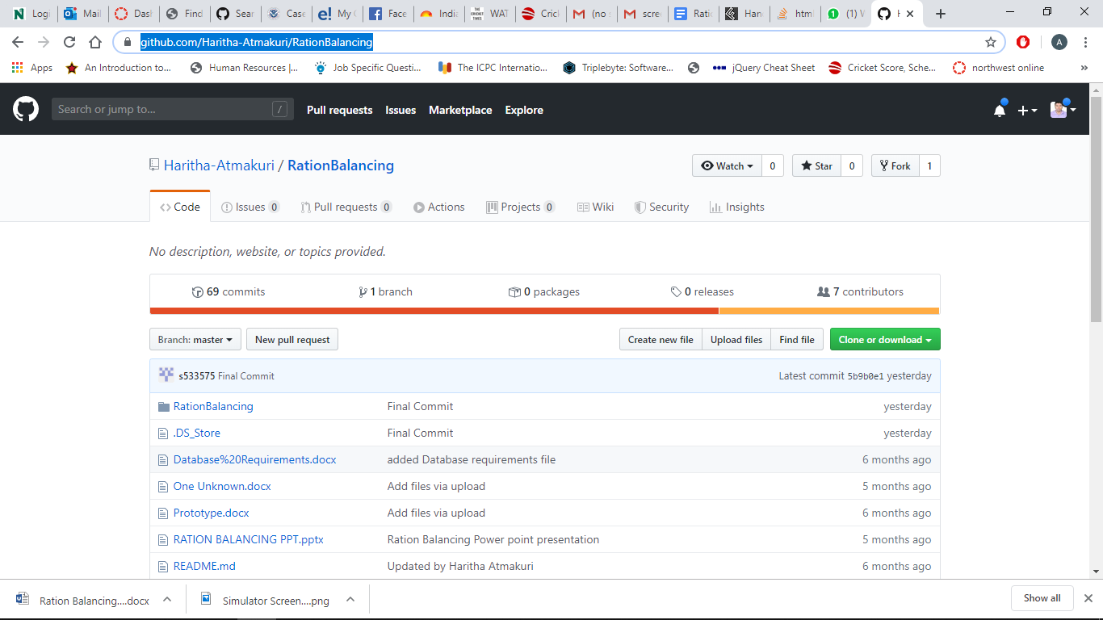

**Step 2:** After downloading you will find a zip file. Unzip the downloaded file and click on Ration Balancing folder. After opening the sub folder, you will find one more Ration balancing folder. Click on the folder then a RationBalancing.xcworkspace is displayed. Open the RationBalancing.xcworkspace.

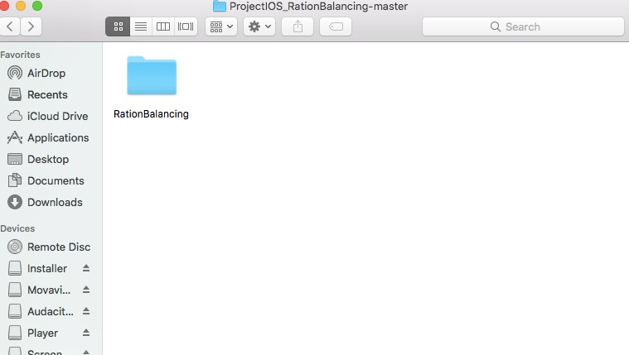

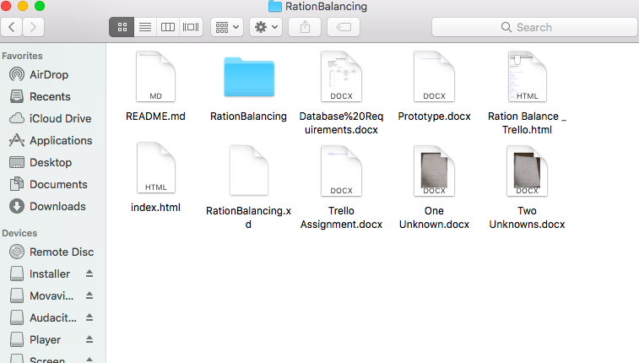

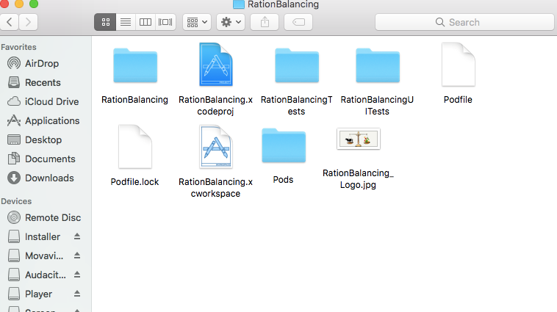

**Step 3:** Once you open the workspace you will find a window as shown in the figure. Then click on the run button.

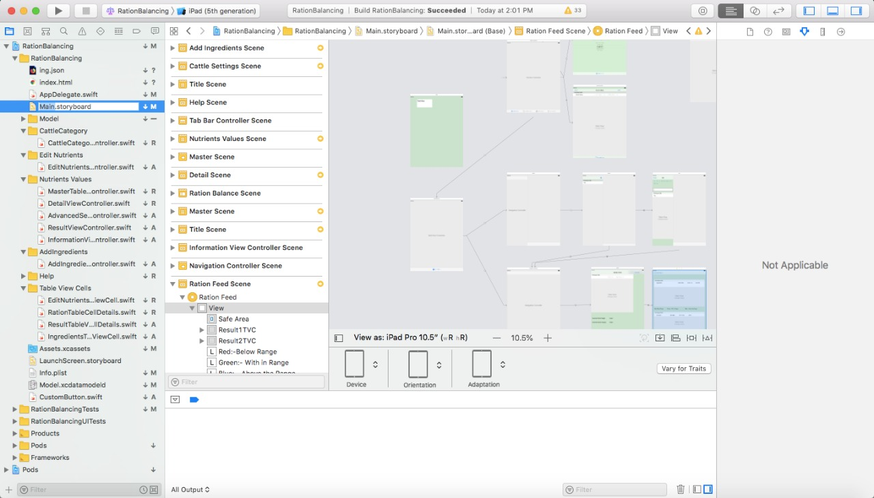

**Steps for installing the application In IPad**

**Step 1:** To see application in IPad for the first time. Repeat step 1 and Step 2 which are mentioned for mac book.

**Step 2:** After that before running the application just connect the USB wire to IPad. Once the application is executed. You see the app in the iPad as shown in figure below.



**Step 3:** No need of doing step 1 and step 2 every time when you are using same IPad. Just follow step 1 and step 2 only when you are running the application on iPad for the first time.

**How to use the application**

**1) Cattle Settings Page: -** This is the landing page of our application. Here the user will select the cattle weight and its corresponding growth requirement for which we have to calculate the ration balancing for the cattle.

User must click on the calculate button in order to proceed forward. Without selecting any of the cattle weight or the growth requirement, it will throw an alert message saying, “Please select the cattle category”.

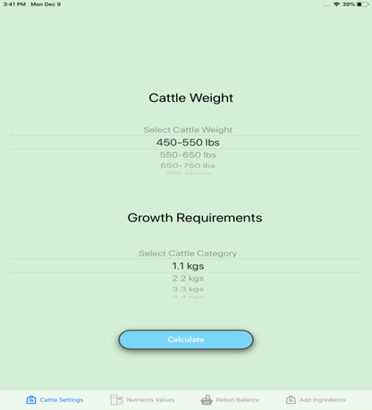

**2a) Nutrient Values Page:** - When user clicks on calculate button in the cattle settings page, it navigates to the Nutrient Values page. Here, the default nutrient values for a cattle weight and growth requirements combination is displayed from the database. The user can edit the nutrient values either directly in the text box or by clicking on ‘+’ or ‘-’ buttons (the value increases or decreases by 0.5).

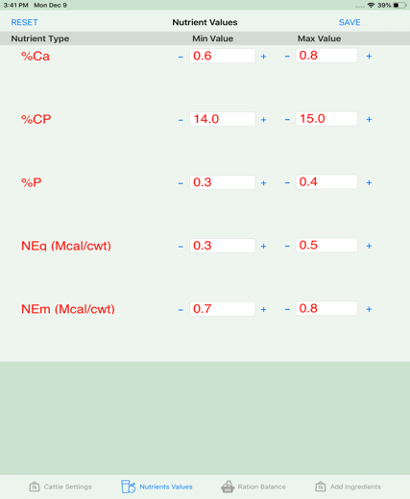

**2b) Incrementing Nutrient Value: -** When the user tries to increase the min value greater than max value, it displays an error message saying, “Min value cannot be greater than max value”.

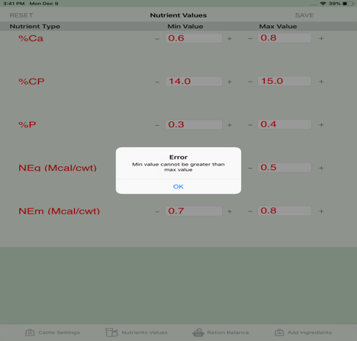

**2c) Decrementing Nutrient Value: -**When the user tries to decrease the max value less than the min value, it displays an error message saying, “Max value cannot be less than min value”.

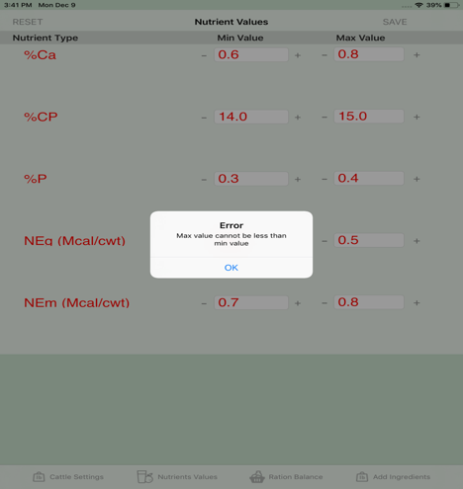

**2d) Reset Nutrient Values: -** The user can change min and max values of the nutrients based on the requirements. The values that are changed are for temporary purpose and user can get back to their previous values on clicking on the RESET button.

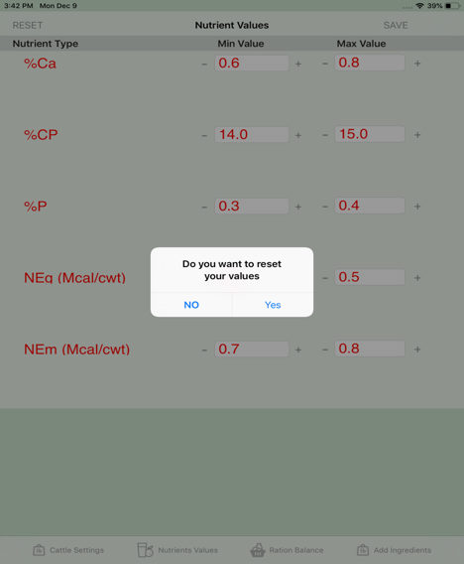

**3a) Ration Balance: -** This is the page where user will be balancing the amount of ration that he needs to fill for the cattle. In this page the user has to select the ingredients that he has to feed for the cattle. This page gives an option of selecting the ingredients out of 279 ingredients. The right side of the page displays the selected ingredients and the bottom of the right side displays the selected cattle weight and the cattle category.

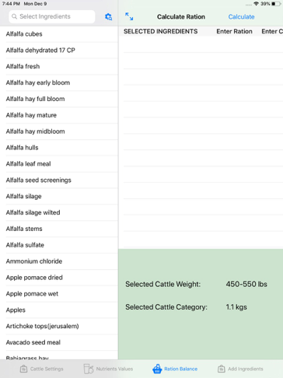

**3b) Select Ingredient Error Message: -** When user tries to click on the calculate button without selecting the ingredient, it will throw an error message saying that “Please select at least one ingredient to proceed forward”. The user must select at least one ingredient to make the calculation for the ration balancing.

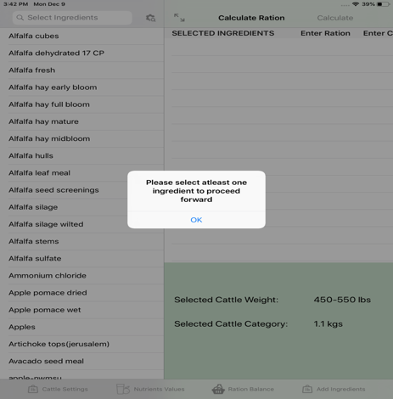

**3c) Selected Ingredient: -** When user clicks on a ingredient, the ingredient will be shown immediately on the right side of the page which is the ingredient that we have selected. On the left side, we can see a checkmark, which tells that it is the selected ingredient.

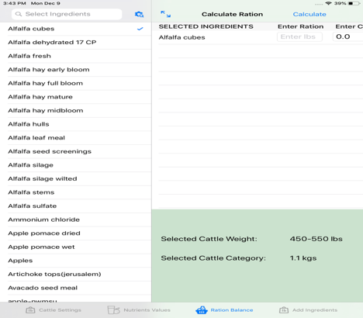

**3d) Selected Ingredient:** To see the selected ingredient in detail, the user can expand the page by clicking on the expand button on the top corner of the right-hand side of a page. User can navigate back to actual page by clicking on the back button named Master.

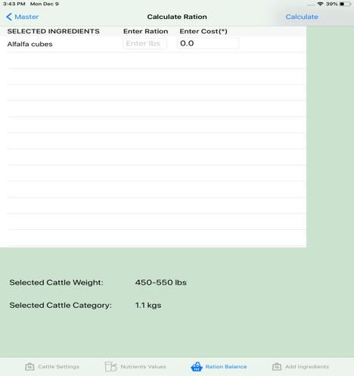

**3e) Ration Balance Calculation Error:** In order to make the ration balancing calculation, we must select two ingredients since there is no point in making the ration balance calculation with a single ingredient.

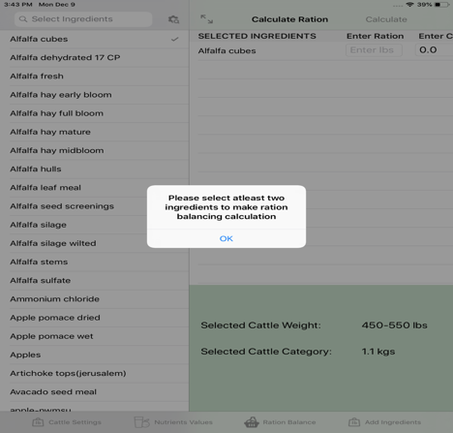

**3f) Advanced Search:** The user can make an advance search based on the alphabetical order which makes an easy way for searching a particular ingredient.

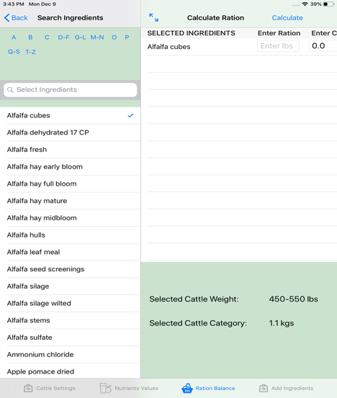

**3g) Non-Double values Error:** When user tries to click on the calculate button without entering the proper input for the cost, it throws an error saying that “Please enter double/integer values for the cost. It even throws the same error, if we try to enter the values that are neither integer nor double values.

It even throws the error, if we don’t enter any values for the cost. The cost values are mandatory fields to enter. Without entering all the cost values, it doesn’t allow us to proceed forward.

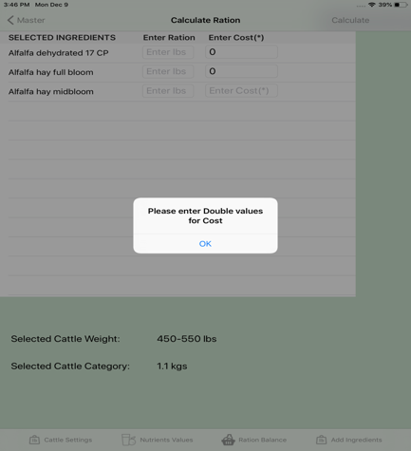

**3h) Ration Balance with selected Ingredients:** This is how it looks like after selecting all the ingredients and with the cost values.

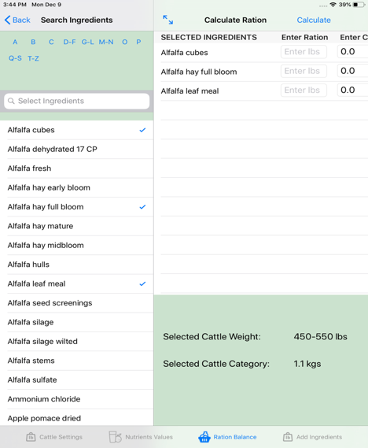

**3i) Result Page for the Ration Balance:** This is the result page of the ration balancing. It is divided into two halves named top part and the bottom part.

The top part consists of the results with ration in pounds of each ingredient that we must feed for the cattle. It also gives us the proportion in the percentage as well.

The below part of the page displays us the result, whether the given cost and the weight in pounds are within the min and the max value of the nutrients for the selected ingredients.

There are different colors that are displayed based on the output values.

**1. Red: -** The red color indicates that the values are below the range and is danger to the cattle.

**2. Green:** - The green value indicates that the values are in the range and is good for the cattle.

**3. Purple: -** The purple color indicates that the values are out of range and is unto to the user whether to proceed with the given proportions or not.

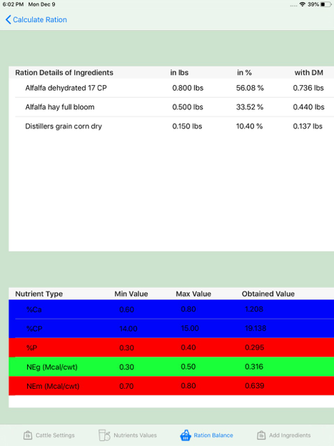

**3j) Delete Selected Ingredient:** The user can delete the selected ingredient by swiping the ingredient to left side which shows the delete button. By clicking on the delete it deletes the selected ingredient from the list.

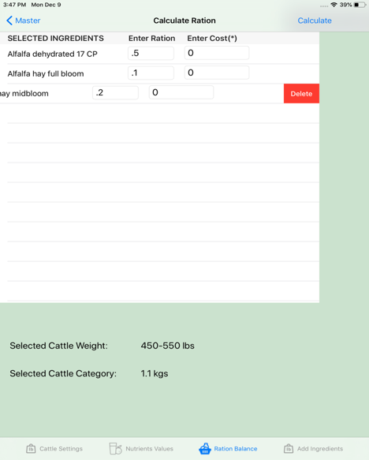

**4a) Add New Ingredients**: This is the add ingredients page where only admin can add ingredients to the ingredients data which are stored in the database with the valid log in credentials.

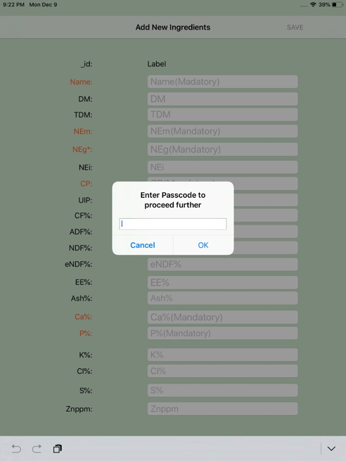

**4b) Add New Ingredients:** When the Admin successfully logs into the add new ingredients page, should be able to add the ingredients. Highlighted fields are mandatory.

